Recruitment, Retention and Wellbeing of Investigators (RRWI)

INVESTIGATION
WELLBEING
STRATEGY

Investigation Wellbeing Strategy

Contents
1.0 Introduction 2
2.0 Wellbeing 2
3.0 National Police Health & Wellbeing Strategy (2024-2026) 4
4.0 Wellbeing Mission 6
5.0 Workplace 7
6.0 Supervisory Role 8
7.0 Working Life 9
8.0 Reward & Recognition 10
9.0 Continuing Professional Development 10
10.0 Team Wellbeing 11
11.0 Operational Wellbeing on long term investigations 11
12.0 Staff Support 12
13.0 Attendance Management 13
14.0 Draft Policy Template 14
1 – Staff Wellbeing Policy 14
15.0 Signposting 15
16.0 Credits 16

1.0 Introduction

1.1 The demands within policing are challenging, complex, and often intense. Work can be mentally challenging, in terms of content, compounded by factors like prolonged attention to detail (e.g., case preparation, disclosure) and time pressure (PACE clock, CPS deadlines, long hours etc.).

1.2 These demands place staff under pressure and we know that staff are vulnerable to both mental and physical ill health as a result of this work.

1.3 It is the responsibility of the leadership team within the department to promote a culture of wellbeing to ensure staff are supported. Department success is intrinsically linked to staff success and their effectiveness is driven by commitment and flexibility.

1.4 It is crucial to maintain goodwill and morale, as police work often relies on this to succeed. If a strong culture of wellbeing and supportiveness can be instilled in the workplace, this will negate the need to implement welfare measures.

2.0 Wellbeing

2.1 The wellbeing of our staff should be at the heart of any department and is crucial in retaining experience, recruiting new staff and building a safe working environment for everyone.

The workplace needs to reflect a positive environment where people can flourish and thrive, not just survive.

2.2 When people are in a positive state of wellbeing at work, they can:

- Develop their potential.
- Be productive and creative.
- Build positive relationships with others.
- Be more resilient and build up positive coping strategies.
- Make meaningful contributions.

2.3 Wellbeing can be broken down into six domains, which highlights that wellbeing is much more than just someone’s physical health.

- 1 – Mental
Security, esteem, cognitive needs, aesthetics, self-actualisation, transcendence.
- 2 – Physical
Biological & physical needs, safety.
- 3 – Emotional / Social
Belongingness
- 4 – Financial
Supporting staff through financial concerns and ensuring they are paid correctly
- 5 – Team
Looking at the wellbeing overall, ensuring fairness and improving morale.
- 6 – Organisational
Ensure organisation priorities are fit for purpose and staff are support appropriately.

2.4 All six areas must be considered to ensure we support a productive workplace environment.

2.5 Policing Risks to Wellbeing
The policing environment brings additional elements that need to be taken into consideration when considering staff wellbeing:

- Increased stress & pressure
- Internal & external scrutiny, particularly negative scrutiny
- High workload
- Physical & mental exhaustion
- Socially alienating
- Psychological damaging
- Demand exceeding supply (resources)

3.0 National Police Health & Wellbeing Strategy (2024-2026)

3.1 Within this strategy, the national police health and wellbeing strategic model (pictured below) illustrates the approach that forces should adopt to optimise workplace wellbeing and work activity.

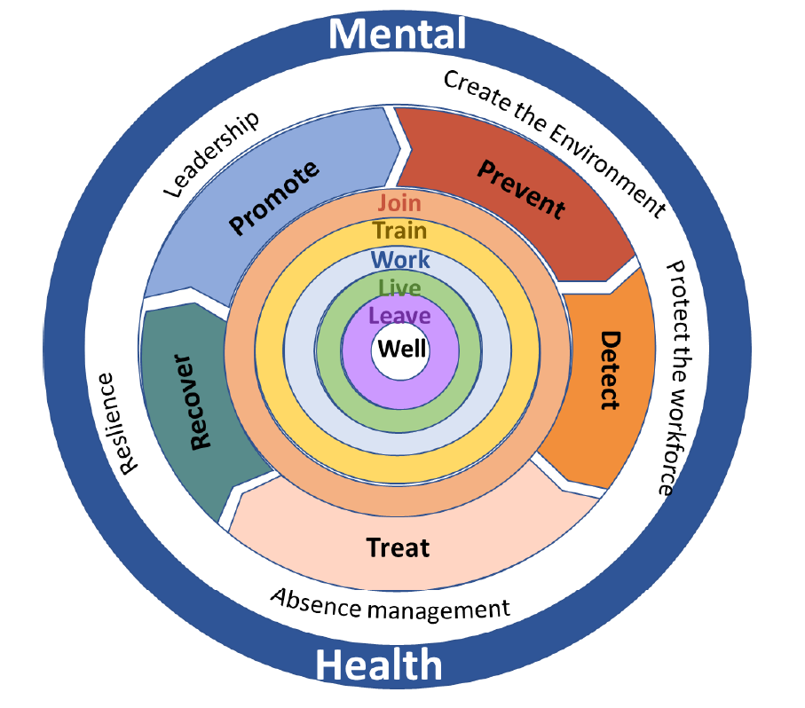

3.2 The core of the model sets out five delivery areas that relate to the police covenant and operational priorities:

- Join well
- Train well
- Work well
- Live well
- Leave well
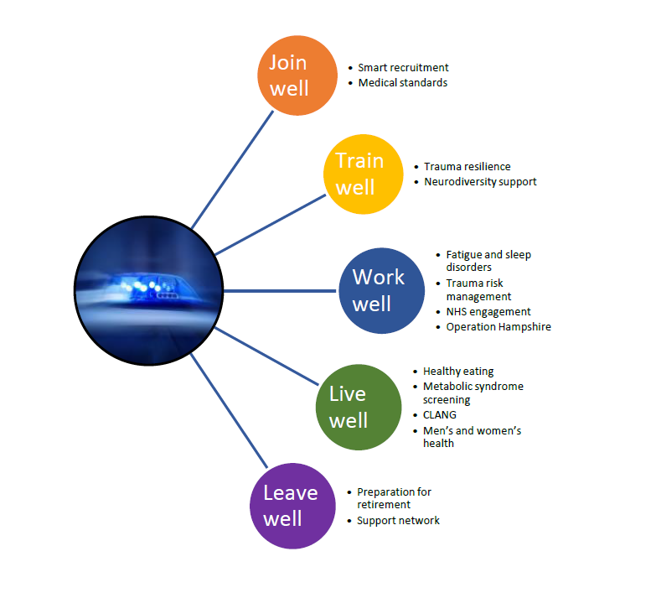
3.3 The report gives useful insight into some of the cost-effectiveness of health and wellbeing promotion, which bespoke wellbeing strategies can draw on to develop senior officer buy-in. The legal requirement for wellbeing is clear, and the moral requirement to look after people’s health and wellbeing is intuitively understood. However, we know that there are individuals who do not understand and some of the data obtained can assist with representations.

3.4 There is a growing body of evidence that a holistic, whole organisational approach to wellbeing positively influences recruitment and retention of personnel and on metrics such as presenteeism and absenteeism. Deloitte has developed a financial model that estimates that measures by employers to improve the mental health of their employees will yield a return, on average, of £5 for every £1 spent.

3.5 The full report is contained here as an attachment, should further and more detailed information be required:

4.0 Wellbeing Mission

4.1 Managers and leaders need to ensure a robust, sensible, and achievable health and wellbeing strategy is in place and is adhered to. This will ensure initiatives, actions and behaviours will assist employees, with a view to them avoiding significant health issues. It provides opportunities for staff to feel supported, included and allow for development. It will also support staff who are unwell to return to work safely.

4.2 Wellbeing strategies must be seen to be practised (‘walk the talk’), to ensure that staff have trust and confidence in their managers and leaders. Implementing policy, without adhering to it, can be corrosive for staff relationships and reduces buy-in. It also fuels cynicism and reduces morale.

4.3 The overall aim of this strategy is to ensure:

- Staff satisfaction
- Staff morale
- Staff retention
- Increased productivity
- Reduced absenteeism or presenteeism
- Enhance relationships between staff and management
- Increase open communications, particularly honest conversations
- Increase trust and confidence in leadership

4.4 South Wales Police carried out an innovation gathering exercise to identify key organisational barriers or hinderances that have a negative impact on investigators.
Read more about ’30 things in 30 days’ here:
https://www.oscarkilo.org.uk/30-things-30-days

4.5 Senior Officer buy-in to wellbeing missions is critical to its success, their attitudes and behaviours will influence the culture.

SLT can be supported in this through the implementation of a Wellbeing Charter.

4.6 SLT can also draw inspiration from the National Police Health & Wellbeing Strategy, where the strategic aim sets out clearly the national vision, objectives and why it matters to the police family. This key strategic document expresses the importance of wellbeing and how, nationally, it is being adopted as a priority.

5.0 Workplace

5.1 What constitutes a ‘workplace’ will vary according to the person, department, and location of staff. Main Office CID ‘workplaces’ are completely different environments to Major Crime or Serious & Organised spaces. These are different again to ROCU and covert facilities.

5.2 There are also differing approaches to agile working and at the personal level workplace / reasonable adjustments.

5.3 Whatever the role and remit, communal workspaces can get messy and untidy, which is not conducive to a positive workplace. Some individuals can be negatively affected by ‘mess’, causing additional (and unnecessary) stress. A clean and tidy workplace creates a nicer environment for everyone to work in and everyone has some personal responsibility for keeping their workplace clean and tidy.

5.4 Where workplaces incorporate / include so called ‘hot desks’, they should be kept clear or personal belongings. This will allow people to feel comfortable accessing and working in this space and not think it belongs to someone else.

5.5 Agile working now plays a central role in policing, across multiple roles and responsibilities. Some roles cannot accommodate agile working, due to the nature of some police roles however, agile working is now universally accepted as a concept to consider.

5.6 Departments split over multiple sites should be open to this way of working and be as flexible as possible. This will assist in recruitment and retention of staff and have a positive impact on wellbeing.

5.7 Managing agile working presents challenges to supervisors, who must maintain regular contact with staff, particularly if their staff are remote and working alone or in very small teams. Contact with staff is key to understanding workload, manage daily tasks, and manage resources. This can be assisted through technology (e.g. MS Teams).

5.8 Supervisors should remain accessible and visible to staff, so they feel they have someone to turn to, even when away from the office.

5.9 Agile working should be considered equally across the team (where possible) to ensure fairness, but this may need to flex according to personal need.

6.0 Supervisory Role

6.1 Police Supervisors (Officers and Staff) are critical to the wellbeing of staff, especially first line managers. Effective first line management can make the most challenging work environments bearable however, ineffective first line managers can make great environments unbearable.

6.2 Supervisors are encouraged to speak to staff regularly and be aware of any warning signs, or triggers, relating to wellbeing. This is vital to support staff and spot the early signs of stress. This can be crucial in identifying and managing conditions like PTSD and burnout but also spotting potential signs of compassion fatigue.

6.3 A number of tools are available to support Supervisors with these honest conversations. In particular, the Wellness Support Plan can guide this conversations to ensure that Supervisors understand their staff, what keeps them well and how they deal with stress (and any other triggers).
Information about the WSP can be accessed through this link:
Wellbeing support plans | Oscar Kilo

6.4 Supervisors should consider holding group / team meetings, particularly if components of the team work remotely from each other. This can prevent silo working and address concerns amongst the team.

6.5 When considering 1-2-1s, group meetings or staff forums, Supervisors could consider Meaning, Safety, Resource (MSR) when it comes to their staff wellbeing.
Do the staff:

- Feel there is meaning in what they are doing?
- Feel safe?
- Feel they have the resources they require to be successful?

7.0 Working Life

7.1 A number of factors can be considered, with regards to nurturing / fostering wellbeing and creating positive working environments. Some of these factors are outlined below:

- Breaks – There are no set breaks and police personnel are notorious for working through refreshment breaks. Managers should encourage their staff to take regular breaks away from their computer.
- Flexibility – Where operationally possible, flexible working hours should be considered to allow for people to have more control over their work/life balance. This can include established processes associated with caring responsibilities but can also include other important commitments in ‘work time’, if operational obligations allow it.
- Email v Speaking – Overuse of email is well established in policing and, whilst this is acknowledged, it has not been possible to reduce its use. This ‘email culture’ can lead to increased workloads and associated work-related stress. Therefore, we should always consider what is sent on email and whether a conversation could be held instead. If an email needs to be sent, consider an accompanying conversation, particularly if it is foreseen that tone / manner has the potential to be misinterpreted.
- Additional Responsibilities – Additional duties are often required to maintain efficiency and effectiveness. These duties should be equitably split, to ensure the whole team have an equal share of additional tasks. These extra roles will assist with the smooth running of the office, give individuals responsibility in the overall department, and ultimately assist in the general wellbeing of the team. Managers must also be cognisant of individual’s needs to take on additional tasks, given this is often required for promotion processes or academic programmes.

7.2 The Wellbeing of Investigators toolkit can assist with information around this and discusses work life balance specifically – https://www.oscarkilo.org.uk/work-life-balance-investigators

7.3 A ‘work-life balance’ is one of the ‘challenge stressors’, set out in the National Police Health & Wellbeing Strategy and is underpinned by Home Office Police Front Line Review: Workshops with police officers and police staff.

7.4 This report identified a number of factors that were perceived to influence wellbeing including: hours, shifts, rest days, leave breaks and commuting; the ability to decompress as well as work life balance as listed.

7.5 Whilst perhaps obvious, it is important to acknowledge the impact of these factors on staff and how each person will react to each factor in different ways. A Wellbeing Strategy, therefore, is a strategic direction and not something that conforms to any one person and their personal needs.

8.0 Reward & Recognition

8.1 Reward & Recognition is a fundamental part of wellbeing and should become embedded as part of a department’s culture.

8.2 Recognition helps staff see that their organisation values them and their contributions to the success of their team and the organisation overall.

8.3 This is particularly key when departments / organisations grow or change. It helps staff build a sense of security in their value to the team, motivating them to continue great work and stay with the team.

8.4 R&R does not need to be on a grand scale and cynicism around people being congratulated for ‘doing their job’ should be challenged. Basic humanity, around simply thanking people for what they do, can go a long way.

8.5 Appropriate recognition, in addition to a simple ‘thank you’ can take many forms, including, but not exclusively:

- Peer-to-Peer recognition
- Verbal or email acknowledgement from supervisors / managers
- Honorariums (Police Staff)
- Commendations (consider scales: Superintendent through to Chief Constable)
- Team building / social events
- TOIL / early finishes

9.0 Continuing Professional Development

9.1 Continuing Professional Development (CPD) is important for all staff, as it enables individuals to reinforce and enhance their skills and filling knowledge gaps. Staff should be encouraged and supported to conduct CPD and where possible given time in work to achieve this.

9.2 Giving staff time to improve themselves, through CPD, brings benefits to an organisation, namely: increased motivation; improved staff retention and recruitment; and improved performance. It also ensures that we adapt and flex to new legislation and policies and continue to learn from best practice and learning reviews.

9.3 Requests to complete CPD that supports a person’s need to carry out their role effectively, should be encouraged (where budgets allow). Staff have personal responsibility around this, combined with supervisory responsibility to identify and support staff CPD, particularly where areas for development are identified.

10.0 Team Wellbeing

10.1 Team ‘comradery’ is essential for morale and efficient team working, including reach out to partner agencies and interoperation working.

10.2 Attitudes and behaviour that enhance team wellbeing should be encouraged wherever possible

10.3 This is particularly important where teams are split, or remote, with plans made to bring teams together for social interactions.

11.0 Operational Wellbeing on long term investigations

11.1 Operational wellbeing is essential, with extensive narrative already around day-to-day support (business as usual). In addition, we need to reflect on and consider the unique impact on wellbeing that come from protracted investigations.

11.2 CID roles, incorporating all elements of investigation, bring pressure and demand associated with the length of enquiries. This is a particular issue at the moment given Criminal Justice backlogs and the amount of time it can take for a case to move through the Court process.

11.3 These additional pressures on investigators need to be carefully considered and any support mechanisms, to alleviate impacts on wellbeing, implemented and maintained.

11.4 This applies to staff at all ranks and roles and is part of integral organisational responsibilities to look at resilience (and put supportive measures in place).

11.5 Departments are encouraged to adopt overall wellbeing strategies, or link to organisational ones. However, in addition to this, SIOs should consider bespoke wellbeing policy or plans for individual investigations.

11.6 These bespoke policies can cover staffing and what resilience and/or support is in place around that staffing. SIOs should have deputies and there should be specific reference to the need for breaks, rest days and annual leave.

11.7 This not restricted to large, complex, or major crime investigations, it can be applied to anything where the SIO considers there are particular risks. This could be where the victim is a child or other vulnerable person. Alternatively, the risk could be in the volume, if an SIO is running a series of investigations (e.g., burglaries or stabbings (GBH)). Carrying a large volume of serious – and protracted – criminal investigations brings unique and added pressures that should be acknowledged.

11.8 The role of an SIO is accepted nationally, by NPCC, as a high-risk role.
11.7 These policies will promote and prioritise staff wellbeing and can be reviewed at relevant operational supervisor review points.

11.8 An example of a specific investigative Staff Wellbeing Policy can be found at 13.0

12.0 Staff Support

12.1 There are various levels of support and tools available to staff and much of this will be specific to regions and/or individual forces. All staff should be made aware of the resources available to them through general communications, bulletin boards, intranets or 1-2-1s.

12.2 Staff should be encouraged to have honest conversations to discuss support and the Wellness Support Plan (WSP), discussed above, can assist with framing these conversations.

12.3 Some force OHU and wellbeing programmes us a pyramid to ‘tier’ the different levels of support that are available. This can assist in assessing what level of support is required and, crucially, where to go next for this support.

An example is presented below for reference:

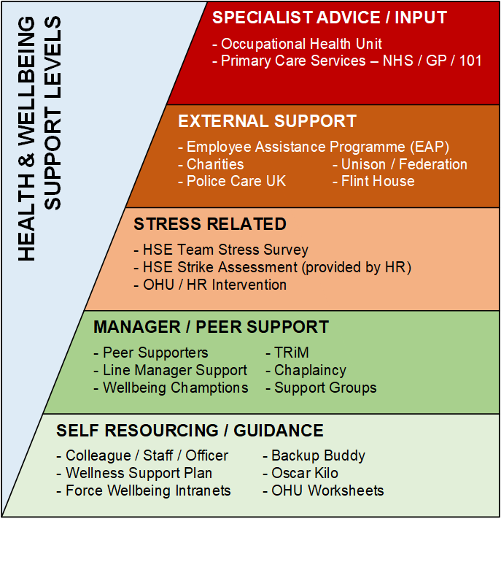

12.4 Within departments there will also be support structured around the nature of the role, particularly those considered to be ‘high risk’. For these roles, local force procedures will set out how they are managed (e.g. psychological screening).

12.5 In addition to local provision, national tools are available to support roles, with ‘Pause Point’ an example of something that can support investigators in high-risk roles.
https://www.oscarkilo.org.uk/pause-point

13.0 Attendance Management

13.1 Each organisation aims to encourage all individuals to maximise their attendance at work while recognising that sometimes people will be unable to attend work due to illness.

13.2 Attendance policy will be force / region specific and cannot be replicated here.

14.0 Draft Policy Template

14.1 SIOs are welcome to use the template below, as part of their policy file, to reflect the importance of staff welfare. The document is only meant to serve as guidance and can be adapted to suit individual needs, in terms of content, style and format.

Policy Number & Title:

1 – Staff Wellbeing Policy

Decision:
Officer / Staff welfare will be at the forefront of this investigation.

Rationale:
The wellbeing of our people is important, not just at a human level, but as a key to the success of the operation. The physical and mental health of our staff/officers (including SIOs / DSIOs) will be affected by this investigation – particularly through secondary trauma.
As such existing wellbeing strategies to be noted and applied to this operation.
This includes guidance, identifying where to go to seek support and enshrining ability to discuss concerns. Key issues noted with this being (** insert specific trigger if present, e.g. child death **), which brings particularly distressing and upsetting elements.
At the initial briefing (to staff) I will note this as a key part and discuss the need to keep an eye on our own welfare and talk, if needed (me included). I am responsible for the staff and will also look to (** specific welfare roles/responsibilities **) to support me in monitoring staff welfare and responding to changes.
Reinforcement of recent communications around support mechanisms (Line Manager, Peer Support, EAP, TRiM etc.). Occupational Health Referrals are available for Line Managers for work related elements.
I am available to discuss welfare concerns of staff, particularly if they are finding the details of this case distressing.

Date / Time:
**/**/**** - **:**

15.0 Signposting

15.1 Specific signposting and services will vary, according to regions and individual forces and are not replicated here. Below are some national links that could be used as a starting point or to gather ideas on how to complete your department’s wellbeing mission.

Need help now?  NHS signposting, relative to urgent mental health issues | www.nhs.uk/get-urgent-help-for-mental-health
Oscar Kilo  The National Police Wellbeing Service | www.oscarkilo.org.uk
Wellbeing of Investigators Toolkit  Provides investigators, their line managers and senior leaders with interventions | www.oscarkilo.org.uk/wellbeing-investigators-toolkit
Helplines & Charities  Some helplines, text services and other sources of information | www.oscarkilo.org.uk/signposts
Police Charities & Services  Some agencies and organisations that support and work with us | www.oscarkilo.org.uk/police-charities-and-services
Staff Associations & Networks  Various staff associations, unions, federations, and networks | www.oscarkilo.org.uk/staff-associations-and-networks
Policing & Public Service Bodies  We are supported by and work with various agencies | www.oscarkilo.org.uk/who-we-work-with
International Resources  Links to international charities & resources | www.oscarkilo.org.uk/international-resources
Mind  The Mind charity website contains a large amount of information covering a whole host of topics | www.mind.org.uk
Police Mutual  Financial support & advice | www.policemutual.co.uk/why-us

16.0 Credits

16.1 Document foundation based on the 2022 05 ERSOU RECU Wellbeing Policy, published by Detective Superintendent Martin Peters (City of London Police)

16.2 Additional content and editing by Detective Inspector Mark Butler (Cambridgeshire Constabulary).

16.3 Content reviewed and signed of by the SIO Working Group, part of the National Recruitment, Retention & Wellbeing of Investigators work programme. This is led by Detective Chief Superintendent Martin Brunning (Cambridgeshire Constabulary), and managed by Sarah-Jane Bray (Thames Valley Police).

16.4 The RRWI programme’s overall lead is Chief Constable Jason Hogg (Thames Valley Police).

Deloitte UK mental health report 2022
Merseyside Police have implemented ‘no email day’ - https://www.oscarkilo.org.uk/no-email-day
Peter Betts and Clare Farmer, Home Office Police Front Line Review: Workshops with police officers and police staff – Summary report FLR Summary chapter draft 27 June (publishing.service.gov.uk)
Further information about this can be found through this link – https://www.oscarkilo.org.uk/SIO Risk

